BIOL 2510 Learning Objectives 3AB
Lecture 3A
- Describe the first line of defense against cellular injury.
- Assign the formed elements of the blood to the correct bone marrow stem cell lineage (myeloid vs lymphoid).
- Describe the structural and functional features of the five major types of white blood cells (three types of granulocytes and the two types of agranulocytes).
- Describe the structural and functional features of primary lymphoid organs and secondary lymphoid organs and tissues.
- Give three examples of antigen presenting cells (APCs) and describe how antigen presenting cells (APCs) travel from body tissues to the secondary lymphoid organs and tissues.
- Explain how an immature lymphocyte becomes a self-tolerant lymphocyte.
- List the ways inflammation (the second line of defense) acts to protect the body from infection and injury.
- Describe the initiation of the inflammatory response by ligand/TLR binding.
- List the cardinal signs of inflammation and explain them in terms of the vascular effects of inflammatory chemicals.
- List the four biochemical pathways that may be activated in response to injury or infection.
- Describe the three processes affected by the end-products of the arachidonic acid pathway.
- Describe the relationships between arachidonic acid pathway enzymes (phospholipase, COX1, COX2) and these anti-inflammatory medications: corticosteroids, aspirin, indomethacin, ibuprofen and celecoxib.
- Discuss the roles fibrin and bradykinin in the inflammatory response.
- Describe the two pathways (classical and alternative) of complement activation.
- Describe the functions of complement proteins (C3a, C3b, C5a, C5b) in the inflammatory response.

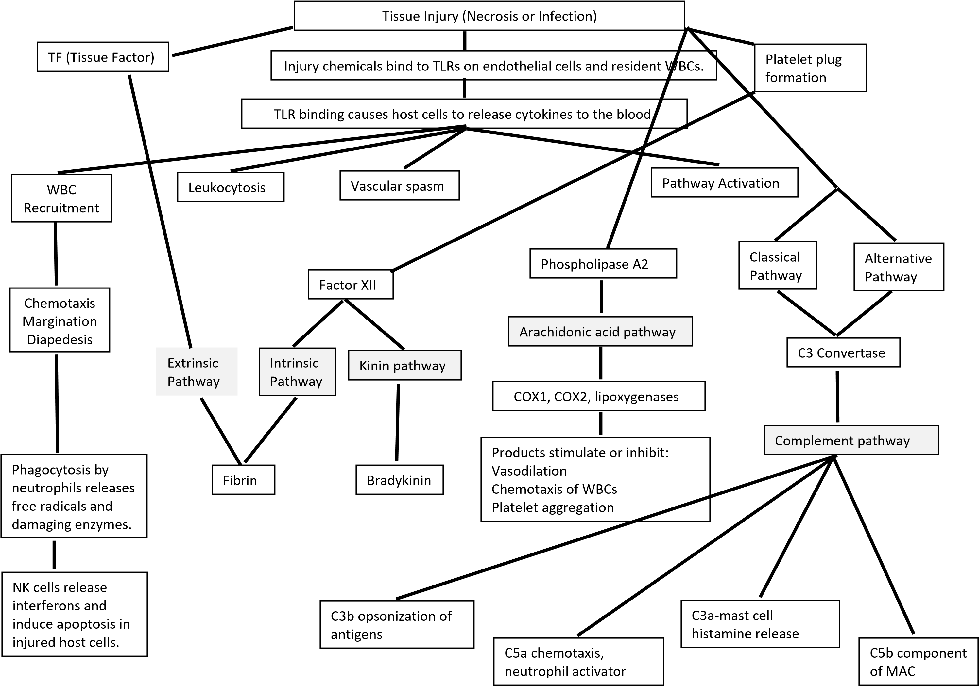
Lecture 3B
- Describe the steps in the recruitment of WBCs to the site of inflammation (leukocytosis, chemotaxis, margination, diapedesis).
- Discuss the source and function of interferons.
- List the roles of macrophages in repairing the damage done to host tissue by inflammation.
- Describe the reason for chronic inflammation and resultant granuloma formation.
- Describe the types and functions of exudates (serous, fibrinous, hemorrhagic, purulent).
- Discuss the clinical manifestation of systemic inflammation and list the cytokines that cause it.
- Describe the clinical tests for systemic inflammation (sedimentation rate, C-reactive protein).
- Describe the two types of pyrogens (internal vs external) and their role in fever generation.
- Differentiate between cell-mediated immunity and humoral immunity with respect to the type of lymphocytes involved.
- Differentiate between a naïve lymphocyte and an effector lymphocyte.
- Draw the process of activation of a naïve cytotoxic T cell against body cells that are infected or malignant. Show the surfaces of the two cells involved and label the following: MCH I, TCR, CD8, a fragment of antigenic protein. Photograph your drawing and insert it here.
- Describe the functions of the effector cells and the memory cells that result from the clonal expansion of an activated cytotoxic T cell.
- An activated cytotoxic T cell differentiates into effector cytotoxic T cells and memory cytotoxic T cells during clonal expansion. Explain what differentiation means at the molecular (DNA) level.
- Draw the process of activation of a naïve helper T cell against an antigen that is presented by a dendritic cell. Show the surfaces of the two cells involved and label the following: MCH II, TCR, CD4, IL-2, IL2 receptor and a fragment of antigenic protein. Photograph your drawing and insert it here.
- Describe the functions of the effector cells and the memory cells that result from the clonal expansion of an activated helper T cell.
- Differentiate between the activities of the two types of effector helper T cells: TH1 cells and TH2 cells.
- Differentiate between NK cell recognition of an injured (infected or malignant) host cell and cytotoxic T cell recognition of an injured host cell with respect to specificity.
- Describe the two ways NK cells and cytotoxic T cells kill a target host cell (perforins/granzymes vs FasL).
- Describe how the antigens involved in cytotoxic T cell activation differ from the antigens involved in helper T cell activation. (Where are the antigens synthesized in each case?)

SUMMARY:

Adaptive Immunity

-
Cell-Mediated Immunity
Humoral Immunity

Intracellular Antigen AAntigenAntigAntigenAntigen

Displayed with MHC I

On
Sick
Body Cells

To Naïve Cytotoxic T cells

Extracellular Antigen

Displayed with MHC II

On APCs (macrophage/dendritic cell)

To Naïve Helper T cells

Extracellular Antigen

Displayed with MHC II

On B cells

To Effector Helper T cells

Effector

Cytotoxic T cells

Memory
Cytotoxic T cells

Wait

Effector

Helper T cells

Memory

Helper T cells

Wait

Effector B cells

(
Plasma Cells)
Kill Sick Body Cells

Perforins/Granzymes

OR

FasL to FasR

Memory

B cells

Wait

Th1

:

*stimulate T cells, NK
cells, macrophages

*secrete IL2, INF gamma

*role in autoimmunity

Th2

*stimulate B cells

*secrete IL4, 5, 10, 13

*role in allergy

Antibodies Released

IgM

IgA

IgD

IgG

IgE

